Pac-Poly-HI-Hi-Menehune face-Vesicular lava

SHAPE \\* MERGEFORMAT 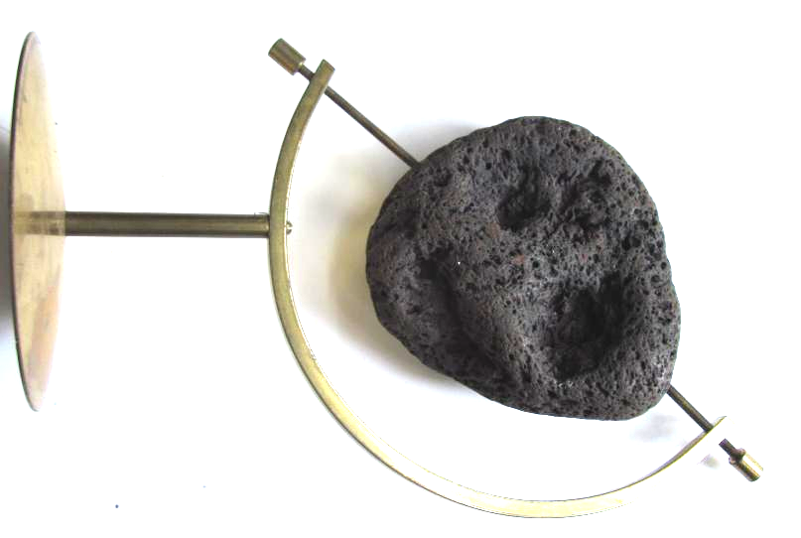

This menehune face was found in Kohala on the island of Hawai'i. It dates to the first settlement of the Island possibly to the earliest period 0-700 CE. Note that the surface has been smoothened by ceremonial use and shows great patina. Extremely rare.